**Microclimatic Amelioration in a California desert system: artificial shelters versus shrubs.**

Nargol Ghazian1*, Mario Zuliani1, and Christopher J. Lortie1, 2.

1Department of Biological Science, York University, 4700 Keele St, Toronto, ON M3J 1P3, Canada

2National Centre for Ecological Analysis and Synthesis (NCEAS), 735 State St #300, Santa Barbara, CA 93101, United States

*Corresponding Author: Department of Biological Science, York University, 4700 Keele St, Toronto, ON, M3J 1P3, Canada. Email: [nargolg1@my.yorku.ca](mailto:nargolg1@my.yorku.ca)

**Abstract**

Anthropogenic factors such as climate change, land use, urbanization, alongside the spread of invasive species are some of the challenges impacting the arid and semi-arid regions of the Western United States and globally. The canopy of many native plants including shrubs and trees not only provides refuge from predators for some animals, but also offers a shelter from climatic stressors for other plants. The canopy of native vegetation can thus be a refuge critical to the persistence of many species locally, and it is vital to better understand its importance for the conservation and recovery of species in these landscapes. In this study, we tested triangular and rectangular artificial canopies relative to the canopy of resident native shrubs. Three light permeabilities including 15%, 50%, and 90% were tested by measuring soil and air temperature with light relative to paired open, non-canopied microsites and shrubs. Shelters offered more stable temperatures and reduction in light compared to the open and were not significantly different from established native shrubs. This suggests that this simple, affordable intervention can provide a stop-gap solution that approximates natural heterogeneity in climate at final scales and a refuge whilst managers and stakeholders at some sites manager and restore native vegetation such as slow-growing, difficult to establish shrubs within this ecosystem.

Keywords: climate change, micro-climate, animals, temperature, light, shelter, conservation, restoration.

**Introduction**

Climate change in arid and semi-arid regions is a critical issue globally. The rate of anthropogenic climate change is rapidly increasing in deserts and semi-arid grasslands (Williams 2014) and species need to adapt through many strategies. These changes in drylands in turn precipitate extensive ecological shifts including species loss (Barrows 2011), range shifts (Bachelet et al. 2016), change in interactions (McCluney et al. 2012), increased invasion by exotic plants (Abatzoglou and Kolden 2011), and additional stress on resident species in these harsh environments (Finch 2012). Factors such as land-use changes including agriculture in drylands (Germano et al. 2011; Eliason and Allen 1997) can further decrease biodiversity by reducing the available terrestrial habitat for plants and animals (Nopper et al. 2018; Irwin et al. 2010; Elmqvist 2013). Vegetation such as shrubs and other foundational plants are often removed or impacted (Sankey et al. 2012). In deserts, animals will not only experience large-scale changes such as drought, but also small scale changes such as relatively more extreme fluctuations in abiotic factors such as temperature (Pugnaire and Luque 2001). Deserts are getting hotter (Allen et al. 2014; Nabhan 2013) and long-term mega-droughts in some regions are relatively more frequent (Guerreiro, Kilsby, and Fowler 2017; Kogan and Guo 2015). This evidence suggests that not only do gross, large-scale changes in climate exert pressure on communities and sensitive species in drylands, but fine-scale changes and fluctuations can potentially further exacerbate, at least, local extirpation (Olden, Poff, and Bestgen 2008), if not extinction (Munguia-Vega et al. 2013). Consequently, refuges, shelters, vegetation, or other attributes in the landscape are likely to enable persistence with changing climate through providing a buffer through variation by reducing the amplitude of variation.

Vegetation is a key aspect of most landscapes in drylands. Mechanistically, different types of vegetation are important for soil water retention as they could lead to different soil bulk densities in drylands (Wang et al. 2013). Shrubs are the dominant vegetation in deserts (Miriti, Joseph Wright, and Howe 2001; Throop et al. 2012), and are thus a useful set of target species to use when examining climate change impacts and strategies used by associated plants and animals to adapt to climate change. Foundation shrubs are able to facilitate other taxa through various mechanistic pathways that include, but are not limited to, seed trapping, abiotic stress amelioration, herbivore protection, magnet pollination, facilitation-mediated secondary seed dispersal, and soil modification (Filazzola and Lortie 2014; Lortie, Filazzola, and Sotomayor 2016). An important agent of structural facilitation is shrub canopy (Filazzola et al. 2017). Canopy microclimates are generally cooler, more humid, and experience lower solar radiation compared to the open sites (Filazzola et al. 2017; Holzapfel and Mahall 1999). Shrubs fulfill a critical role; hence, more species are associated with shrubs than open spaces (Lortie, Filazzola, and Sotomayor 2016). California is home to a diversity of dryland landscapes, dominated by many species of shrubs (Stuart and Sawyer 2001). *Ephedra Californica* (Mormon Tea) is a common foundation shrub species that benefits other plants (Lortie et al. 2018) and animals (Ivey et al. 2020). Heterogeneity in microclimate and habitat at fine-scales is important of the maintenance of biodiversity and vegetation including shrubs provide a key component of this variation in many systems, including deserts (Fuhlendorf et al. 2017; Thorhallsdottir 1990). Structural diversity alongside species diversity is crucial to many landscapes (Brooks 1999; Cowling et al. 1999; Morris 2000). Hence, it is vital to advance the theory and application by A) testing shrubs as a thermal shelters and sources of fine-scale heterogeneity relative to open-gap microsites B) directly test small, shrub-sized, shelters both as a mean to more directly explore canopy effects without the biotic components of vegetation including litter, soil effects, or roots, and to examine a simple solution that can promote micro-heterogeneity in deserts and provide temporary structural diversity. Furthermore, it is important to direct and sample value of more shelters in some dryland systems as a form of thermal refuge and alternate modes of conservation whilst landscape recovery is made and new shrubs are grown.

Shrubs can be both keystone and foundation species in deserts. A keystone species (predator) is one that generally occurs in low abundances and occupies a high trophic level, but controls the density and diversity of other ecologically significant species (Mills and Doak 1993). On the other hand, a foundation species is locally abundant, common, and occupies a lower trophic level, yet they also create locally stable conditions required by other species (Attum and Eason 2006). Foundation shrubs in dryland systems are typically slow-growing (Sawyer, Keeler-Wolf, and Evens 2009), difficult to establish in areas impacted by climate change (Meyer and Pendleton 2005), and frequently cleared by ranchers for livestock farming (Webb and Stielstra 1979). Hence, it would be ideal to have the capacity to mimic shrubs to augment and enhance low shrub cover areas and serve as stop-gap tools for conservation. Artificial canopies can provide an important surrogate test for canopy effects in drylands and there is a relatively long history of their use in ecology. Rainout shelters/drought nets and Open-Top-Chambers (OTC) have been used to study the change in a variety of abiotic parameters such as CO2, temperature, soil temperature, solar radiation, and humidity (Yahdjian and Sala 2002; Marion et al. 1997). Although these shelters are effective, they can be expensive to build and may be difficult to assemble in a short period of time. Rainout shelters/drought nets used in semi-desert grassland studies have proven to be effective in altering precipitation, yet they have minimal impact on changing other variables such as air and soil temperature, humidity, and light (English et al. 2005; Gherardi and Sala 2013). On the other hand, OTCs have been experimentally used to increase temperature in plant studies in high-latitude ecosystems (Marion et al. 1997). Although these shelters are effective at manipulating different abiotic parameters, they are typically larger in size (not shrub-sized). It is therefore key to take advantage of the variability in temperature and light in drylands to explore the effects of artificial shelters that are inexpensive, easily-built, and comparable to shrub micro-climate effects in the same system.

The concept of shade from higher and more variable temperatures in drylands is an important idea to explore experimentally for conservation and restoration. Using a California desert ecosystem, we tested an inexpensive shelter alternative to shrubs form, shape, and permeability in concert with pared microclimatic measures under shrubs and these structures. We hypothesized that artificial shelters can mimic the micro-climate shelter effects of shrub canopy on temp and light intensity. The following predictions tested included: 1) shape of shelter is important, 2) UV permeability can shift light and temperature regimes experienced, 3) a combination of these two key factors in constructing shelters can effectively mimic some of the effects of shrub canopies at these fine-scales, and 4) climate is experienced differently at the microsite level and it is more ecologically-relevant than coarser-scale weather station data. Using shade cloth permeabilities of 15%, 50%, and 90%, we examined the direct shade effects of the canopy on the thermal environment in order test the shelter hypothesis. A deeper understanding of these physical structures impacts at fine-scales are important as they can inform some of the ecology of these changes.

**Materials & Methods**

***Study Site***

This study was conducted in Panoche Hills Management Area located on the western edge of the San Joaquin Valley, California (Bureau of Land Management; 36°41.78′ N, 120°47.89′ W) (P; Supplementary Appendix). The regional climate can be characterized as arid/semi-arid. The average annual precipitation is 25.5 cm with an annual low and high temperature of 10.4 °C (50.72 °F) and 24.6 °C (76.3 °F), respectively. Winter and fall are considered to be the wettest seasons. The mean temperature observed in May is 20.4 °C (68.72 °F) and 23.7 °C (74.66 °F) in June (Los Baños Weather Station, <http://www.usclimatedata.com/>). The area is an *Ephedra californica* parkland, spread randomly between invasive grasses including *Bromus madritensis ssp. Rubens, Bromus hordeaceus, Erodium cicutarium* and *Schismus barbatus*  (Filazzola et al. 2017)*.* The study took place between May 20th to June 12th, 2019.

***Shelter, Shrub, & Open Microsite Deployment***

Shelters were constructed using PVC piping and UV permeable shade cloths at three permeabilities including 15%, 50%, and 90%. The open at 0% light blockage served as the procedural control as the frame was still deployed. The cloths were attached to the PVC using zip ties (Figure 1). Table A (Supplementary Appendix) describes the number of pieces at specific dimensions and diameter needed to build each triangle or square shelter. There were six replicates of each shape. Two for each blockage percentage for a total of 12 replicates. Pipes were slid onto metal stakes and secured into ground for stability (Supplementary Appendix; I). Latitude and longitude coordinates of each shelter-open pair were also recorded (B; Supplementary Appendix).

Shrub-open pairs were deployed in the same area as shelters. There were a total of 7 shrub-open pairs for a total of 14 microsites. Shrub dimensions at the x, y, and z planes were recorded alongside the latitude and longitude coordinates. The open microsite was directly 2 meters away from the shrub at random orientation generated by a number table. The ground surrounding the shrub was mostly bare or contained patches of *Bromus madritensis ssp. Rubens.*

***Shelter Construction***

Rectangular (referred to as square in stats) shelters consisted of two sides with two 61 cm ½ inch pipes facing the ground connected to a 61 cm ¾ inch pipe using a 90° elbow. Triangular shelters were built using a 75 cm ¾ inch top pipe connected to a ½ inch to ¾ inch adapter. The adapter was then attached to a ½ inch 3-way 90° elbow fitted with two 61 cm ½ inch pipes. Cloths were used to cover two sides of the triangular shelters and three sides of the rectangular shelters. The cardinal direction or orientation of each shelter was decided using a random number table and recorded. Shelters were inspected weekly throughout deployment.

***Shelter Micro-climatic Measurements***

To measure the difference in light and temperature within shelters and between shelters and open microsites, Onset HOBO Temperature/Light Pendant (8K) loggers were placed inside and directly outside to the right of the shelters. A total of 24 pendants were used, where each pendant was tied to a plastic stake using a zip tie, recording data at 1 hour intervals. Stakes were hammered into the ground until stable with ~10 cm remaining above ground. This was done to ensure that logger data were less-influenced by ground cover and true ambient conditions both inside and in the open were recorded. Air temperature (°F) and light intensity (lum/ft2) were recorded hourly. Loggers were placed out mid-May and collected in mid-June to account for spring-summer seasonal variation.

***Shrub-open Micro-climatic Measurements***

A set of Onset HOBO Temperature/Light Pendant (8K) (one soil and one ambient) were placed below the base of *Ephedra californica* shrub canopies to log temperature and light intensity data in 1 hour intervals. The ambient pendants were secured to pegs using the same protocol as above. Latitude and longitude coordinates of each shrub were recorded upon deployment of loggers. There were 7 shrub microsites resulting in a total of 14 loggers being used (B; Supplementary Appendix).

***Macro-climatic Measurements***

Hourly weather data were downloaded for the study site for the total duration of the study (Los Baños Weather Station at 37°03.30′N, 120°51.00′W, <http://www.usclimatedata.com/>). Date, air and soil temperature (°F) with solar radiation (W/m2) were exported from this site and published (citation).

***Statistical Analyses***

All statistics were performed using R version 4.0.0 (R Core Team 2020). Code is published on Zenodo (citation) and micro-climate data are published on Figshare (citation). Q-Q plots were used to examine the distribution of data and to check for normality and homoscedasticity (Schützenmeister, Jensen, and Piepho 2012). The relationship between temperature and light intensity was examined using Kendall’s rank correlation (non-parametric, continuous data). Generalized Linear Models (GLM) were used to compare temperature, light intensity, cover type, and microsite (Nelder and Wedderburn 1972). GLM dispersion parameters alongside AIC scores were used to compare and select the appropriate family to fit to models (Richards, Whittingham, and Stephens 2011). Gaussian family distribution was fitted to temperature models, while the quasi-Poisson family was fitted to light intensity. Post-hoc tests were done using the function *emmeans* from the *emmeans* R package (Lenth and Herve 2019). Relative Interaction Indices (RII) (Armas, Ordiales, and Pugnaire 2004) were used to estimate the strength and direction of the microsite effect for temperature as follows:

Where ASand Acare the parameters for ambient temperature under the shelter or shrub and the paired open microsite. The index values range from -1 to +1. For temperature, a positive value indicates that the shrub or shelter microsite is hotter relative to the open, or less ameliorated (Sotomayor and Drezner 2019). A value of 0 indicates a neutral effect.

**Results**

***Temperature Effects***

Temperature significantly increased with light intensity (Kendall’s tau= 0.281, p=0.0001; non-parametric, continuous data Figure L; Supplementary Appendix). The relationship between the two variables was positively linear regardless of the microsite. We compared daily mean temperatures at each microsite and found that the triangular and square shelter had the lowest estimated marginalized mean (EMM) (70.5 ± 0.467 °F and 72.7 ± 0.378 °F, respectively), whilst the open experienced the highest EMM (73.9 ± 0.219 0.467 °F) (Table 1). Triangle was significantly cooler than the open (Figure 2 and Table 3, post-hoc test, p= 0.0001) (E; Supplementary Appendix). This was also the case for the square microsite (Figure 2 and Table 3, post-hoc test, p=0.0001). Additionally, higher temperatures were seen at a greater frequency in the open versus under the shrub or shelter microsites (Figure 4). The EMM of RII for temperature was the lowest for square (-0.00308 ± 0.00408) (H, N, and O; Supplementary Appendix), but it was not significantly lower than shrub or triangle RII. Finally, the coarser-scale weather station data showed a lower EMM compared to the micro-climate data (68.3 ± 0.872 °F) and was significantly lower than the open, shrub, and square microsites (Figure 2 and Table 3, post-hoc test, p= 0.0001) (E; Supplementary Appendix), but not triangle.

***Light intensity effects***

Daily mean light intensities were used to compare between microsites. The square microsite experienced the lowest EMM in light intensity (7.424± 0.04371 lum/ft2), followed by triangle (7.529± 0.05124 lum/ft2), whereas the open experienced the highest EMM (8.111± 0.018 lum/ft2) (Table 2). Both square and triangle experienced significantly lower light intensities compared to the open (Figure 3 and Table 3, post-hoc p= 0.0001) (F; Supplementary Appendix) and performed similarly to shrubs. Further analyses demonstrated there was a significant interaction term between shape and cover type for triangle with the lowest temperature experienced at 90% blockage (Table 4 and 5).

**Discussion**

Shrubs and structural heterogeneity are important components of ecosystems relevant to the conservation and restoration of other plants and animals. A shelter, vegetation, or artificial of any sort in deserts provides amelioration or even just differences in the temperature and light at fine-scales that provides plants and particularly animals with thermal options (Ivey et al. 2020; Attum and Eason 2006). In plants, this can take the form of different germination conditions (Szwagrzyk, Szewczyk, and Bodziarczyk 2001; Went 1949). In animals, this can include thermoregulation (Parmenter and MacMahon 1983), foraging for prey under canopies (Barbosa and Castellanos 2005), or habitat for burrows and dens (Filazzola et al. 2017). The hypothesis that artificial shelters can provide a similar thermal and light habitat to shrub canopies was supported by this study. Both shapes approximated the canopy effects of the nearby *Ephedra californica*; however, triangle at 90% was slightly better than all other shelter combinations. We also hypothesized that microsite-level climate is experienced differently than coarse-scale climate. Coarser-scale climate was cooler than all microsite compared to the logger data, except at triangle. This evidence suggest that shelters can provide and important mechanism or tool for stakeholders to provide habitat for plants and animals either as a temporary stepping stone in restoration strategies or as a means to enhance habitat quality through simple and cost effective interventions.

Mean daily ambient temperatures were generally cooler under the triangular and square shelters relative to the open and closely approximated canopy effects of *E. californica*. Temperature under the square canopy experienced the greatest amelioration effect and was closest to the facilitation effect of *E. californica*. Although, daily mean temperatures were cooler under both shelter types relative to the open, the triangle generally showed slightly colder temperatures. Additionally, both shelters closely emulated the light effects of *E. californica* on the thermal environment*,* but triangle was marginally superior at the 90% blockage. In natural vegetation, leaf area index (LAI) is a dimension-less value of the leaf area per unit ground area (Breda 2003). The cooling effect on canopy air temperature and shade effectiveness is directly related to LAI, with species of higher LAI values generally providing a greater cooling effect compared to other species (Tukiran 2016). LAI is also related to photosynthetic rates of plants as thicker branching and twigs result in higher LAIs, thus influencing the amount of incoming sunlight (Wilfong, Brown, and Blaser 1967). Similar to vegetation, we suspect that the geometrical structure of a triangular prism results in a greater LAI, therefore providing a slightly greater cooling-effect compared to the square (rectangular prism). Furthermore, it is reasonable to assume that the LAI of the square shelter is more closely related to that of the shrub *E. californica.* We can also compare higher levels of branching and twigs in natural vegetation to the higher blockage percentage of shade cloths, which can explain the significant cooling effect under triangle at 90% percent relative to the square. Thus, the decision to select a shape will highly depend on the goal of the stake-holder: to lower temperature as much as possible relative to the open, or to more closely emulate the canopy effects of a foundational species such as those of *E. californica.* Overall, we recommend the triangular shelter at 90% UV blockage for a low light-gap canopy that meets both goals mentioned above.

Mean daily temperatures recorded by *U.S. Climate* were significantly colder than micro-site level logger data. This was the case for almost all microsites excluding the triangular canopy. A study conducted by Kollas et al. (2014) found that weather-station predicted minimum temperatures were colder than temperatures recorded on site. In certain ecosystems like forests, canopies can screen thermal radiative losses from the ground and the understory at night, resulting in higher daily absolute minimum temperatures compared to the open (bare, or almost bare ground) (Geiger 2018). It’s plausible to assume that canopies in arid ecosystems also absorb radiative losses from the ground, thus resulting in hotter daily ambient temperatures recorded by loggers. Additionally, the ground at Panoche Hills is not completely bare and is, in fact, covered with a thick, dry layer of golden-coloured Mediterranean grasses during the spring and summer periods, which can reflect light back to the loggers; therefore, increasing the temperature recoded. This is consistent with the idea that dark surfaces typically absorb more incident radiation than light-coloured, high reflectance surfaces (Stuart-Fox, Newton, and Clusella-Trullas 2017). Another study by Lathlean et al. (2011) also reported significantly lower air temperatures when measured via *in situ* loggers and concluded that coarse-scale data were ineffective at capturing extremes in air temperature variability. This demonstrates the importance of micro-climatic scaling as being more biologically and ecologically-relevant when looking at interactions across taxa.

Shaded microhabitats are a vital components that increase the thermal and structural heterogeneity for a variety of animals such as ectotherms, in addition to providing refuge (Bauwens, Hertz, and Castilla 1996; Diaz and Cabezas-Diaz 2004). There is an important positive relationship between richness and environmental heterogeneity, and environmental heterogeneity has been known to impact community dynamics (Yang et al. 2015). Environmental heterogeneity can increase the potential species able to colonize different microsites (Lundholm 2009). In a way, micro-environmental heterogeneity is important because it provides different niches for a variety of species. Our data support that shelters too can act similar to vegetation and thus increase the thermal heterogeneity within a given environment. Furthermore, it shows that shelters, shrubs, and even open microsites may play an important role in a species’ ability to thrive in a given ecosystem. In California, climate change is interfering with wildfire regimes and altering biological communities (Bishop et al. 2019). Not only can post-disturbance recovery of vegetation be slow(Berry et al. 2016), but competition and invasion by non-natives are amongst other challenges slowing the recruitment of native vegetation (Bowman et al. 2009, 2011). Hence, the benefit of artificial shelters as a mode of conservation is evident, whilst other efforts are made to re-establish the native community and the natural vegetation has had the time and resources to re-emerge.

Signs of human-induced climate change is already visible in a variety of ecosystems. Species all around the world face changes in distribution and abundance due to migration and range shift (Midgley et al. 2002). This change will impact the physiology, growth, and productivity of biota(Cannell 1998), as well as their behaviour( Walther, Burga, and Edwards 2001). Given the current rates, it will not be long before species can no longer physiologically and behaviourally mitigate the impacts of climate change. Animals such as lizards may already be over-expending energy when trying to thermoregulate(Vickers, Manicom, and Schwarzkopf 2011). This study suggests that shelters offer a mechanism to create climate refuges as a temporary solution or a long-term strategy, and as an effective form of interference for today’s every-growing anthropogenic disturbances.

**Funding**

This research was made possible through a Natural Sciences and Engineering Research Council of Canada (NSERC) grant awarded to C.J.L. and the Mitacs Globalink award, alongside York University Faculty of Graduate Studies (FGS) fund granted to N.G. and M.Z.

**Acknowledgements**

We are thankful to BLM for allowing us to conduct research in their land. We are grateful to M. MacDonald for her help in designing the project and editing the manuscript. We thank M. Westphal for his help during field work. We also thank J. Braun, M. Owen, and S. Haas for their feedback on statistical analyses.

**Work Cited**

Abatzoglou, John T., and Crystal A. Kolden. 2011. “Climate Change in Western US Deserts: Potential for Increased Wildfire and Invasive Annual Grasses.” *Rangeland Ecology & Management* 64 (5): 471–78. https://doi.org/10.2111/REM-D-09-00151.1.

Allen, Michael F., C.W. Barrows, Michael D. Bell, G Darrel Jenerette, Robert F. Johnson, and Edith B. Allen. 2014. “Threats to California’s Desert Ecosystems.” 42 (2).

Armas, Cristina, Ramón Ordiales, and Francisco I. Pugnaire. 2004. “MEASURING PLANT INTERACTIONS: A NEW COMPARATIVE INDEX.” *Ecology* 85 (10): 2682–86. https://doi.org/10.1890/03-0650.

Attum, Omar A., and Perri K. Eason. 2006. “Effects of Vegetation Loss on a Sand Dune Lizard.” Edited by Ribic. *Journal of Wildlife Management* 70 (1): 27–30. https://doi.org/10.2193/0022-541X(2006)70[27:EOVLOA]2.0.CO;2.

Bachelet, D., K. Ferschweiler, T. Sheehan, and J. Strittholt. 2016. “Climate Change Effects on Southern California Deserts.” *Journal of Arid Environments* 127 (April): 17–29. https://doi.org/10.1016/j.jaridenv.2015.10.003.

Barbosa, Pedro, and Ignacio Castellanos, eds. 2005. *Ecology of Predator-Prey Interactions*. Oxford ; New York: Oxford University Press.

Barrows, C.W. 2011. “Sensitivity to Climate Change for Two Reptiles at the Mojave–Sonoran Desert Interface.” *Journal of Arid Environments* 75 (7): 629–35. https://doi.org/10.1016/j.jaridenv.2011.01.018.

Bauwens, Dirk, Paul E. Hertz, and Aurora M. Castilla. 1996. “Thermoregulation in a Lacertid Lizard: The Relative Contributions of Distinct Behavioral Mechanisms.” *Ecology* 77 (6): 1818–30. https://doi.org/10.2307/2265786.

Berry, Kristin H., James F. Weigand, Timothy A. Gowan, and Jeremy S. Mack. 2016. “Bidirectional Recovery Patterns of Mojave Desert Vegetation in an Aqueduct Pipeline Corridor after 36 Years: I. Perennial Shrubs and Grasses.” *Journal of Arid Environments* 124 (January): 413–25. https://doi.org/10.1016/j.jaridenv.2015.03.004.

Bishop, Tara B. B., Richard A. Gill, Brock R. McMillan, and Samuel B. St. Clair. 2019. “Fire, Rodent Herbivory, and Plant Competition: Implications for Invasion and Altered Fire Regimes in the Mojave Desert.” *Oecologia*, November. https://doi.org/10.1007/s00442-019-04562-2.

Bowman, D. M. J. S., J. K. Balch, P. Artaxo, W. J. Bond, J. M. Carlson, M. A. Cochrane, C. M. D’Antonio, et al. 2009. “Fire in the Earth System.” *Science* 324 (5926): 481–84. https://doi.org/10.1126/science.1163886.

Bowman, David M. J. S., Jennifer Balch, Paulo Artaxo, William J. Bond, Mark A. Cochrane, Carla M. D’Antonio, Ruth DeFries, et al. 2011. “The Human Dimension of Fire Regimes on Earth: The Human Dimension of Fire Regimes on Earth.” *Journal of Biogeography* 38 (12): 2223–36. https://doi.org/10.1111/j.1365-2699.2011.02595.x.

Breda, N. J. J. 2003. “Ground-Based Measurements of Leaf Area Index: A Review of Methods, Instruments and Current Controversies.” *Journal of Experimental Botany* 54 (392): 2403–17. https://doi.org/10.1093/jxb/erg263.

Brooks, Matthew. 1999. “Effects of Protective Fencing on Birds, Lizards, and Black-Tailed Hares in the Western Mojave Desert.” *Environmental Management* 23 (3): 387–400. https://doi.org/10.1007/s002679900194.

Cannell, M. 1998. “UK Conifer Forests May Be Growing Faster in Response to Increased N Deposition, Atmospheric CO2 and Temperature.” *Forestry* 71 (4): 277–96. https://doi.org/10.1093/forestry/71.4.277.

Cowling, R. M., R. L. Pressey, A. T. Lombard, P. G. Desmet, and A. G. Ellis. 1999. “From Representation to Persistence: Requirements for a Sustainable System of Conservation Areas in the Species-Rich Mediterranean-Climate Desert of Southern Africa.” *Diversity <html_ent Glyph="@amp;" Ascii="&amp;"/> Distributions* 5 (1–2): 51–71. https://doi.org/10.1046/j.1472-4642.1999.00038.x.

Diaz, J. A., and S. Cabezas-Diaz. 2004. “Seasonal Variation in the Contribution of Different Behavioural Mechanisms to Lizard Thermoregulation.” *Functional Ecology* 18 (6): 867–75. https://doi.org/10.1111/j.0269-8463.2004.00916.x.

Eliason, Scott A., and Edith B. Allen. 1997. “Exotic Grass Competition in Suppressing Native Shrubland Re-Establishment.” *Restoration Ecology* 5 (3): 245–55. https://doi.org/10.1046/j.1526-100X.1997.09729.x.

Elmqvist, Thomas, ed. 2013. *Urbanization, Biodiversity and Ecosystem Services: Challenges and Opportunities: A Global Assessment ; a Part of the Cities and Biodiversity Outlook Project*. Springer Open. Dordrecht: Springer.

English, N.B., J.F. Weltzin, A. Fravolini, L. Thomas, and D.G. Williams. 2005. “The Influence of Soil Texture and Vegetation on Soil Moisture under Rainout Shelters in a Semi-Desert Grassland.” *Journal of Arid Environments* 63 (1): 324–43. https://doi.org/10.1016/j.jaridenv.2005.03.013.

Filazzola, Alessandro, and Christopher J. Lortie. 2014. “A Systematic Review and Conceptual Framework for the Mechanistic Pathways of Nurse Plants: A Systematic Review of Nurse-Plant Mechanisms.” *Global Ecology and Biogeography* 23 (12): 1335–45. https://doi.org/10.1111/geb.12202.

Filazzola, Alessandro, Michael Westphal, Michael Powers, Amanda Rae Liczner, Deborah A. (Smith) Woollett, Brent Johnson, and Christopher J. Lortie. 2017. “Non-Trophic Interactions in Deserts: Facilitation, Interference, and an Endangered Lizard Species.” *Basic and Applied Ecology* 20 (May): 51–61. https://doi.org/10.1016/j.baae.2017.01.002.

Finch, Deborah M. 2012. “Climate Change in Grasslands, Shrublands, and Deserts of the Interior American West: A Review and Needs Assessment.” RMRS-GTR-285. Ft. Collins, CO: U.S. Department of Agriculture, Forest Service, Rocky Mountain Research Station. https://doi.org/10.2737/RMRS-GTR-285.

Fuhlendorf, Samuel D., Richard W. S. Fynn, Devan Allen McGranahan, and Dirac Twidwell. 2017. “Heterogeneity as the Basis for Rangeland Management.” In *Rangeland Systems*, edited by David D. Briske, 169–96. Springer Series on Environmental Management. Cham: Springer International Publishing. https://doi.org/10.1007/978-3-319-46709-2_5.

Geiger, Rudolf. 2018. *The Climate Near the Ground.* Franklin Classic Trade Press.

Germano, David J., Galen B. Rathbun, Lawrence R. Saslaw, Brian L. Cypher, Ellen A. Cypher, and Larry M. Vredenburgh. 2011. “The San Joaquin Desert of California: Ecologically Misunderstood and Overlooked.” *Natural Areas Journal* 31 (2): 138–47. https://doi.org/10.3375/043.031.0206.

Gherardi, Laureano A., and Osvaldo E. Sala. 2013. “Automated Rainfall Manipulation System: A Reliable and Inexpensive Tool for Ecologists.” *Ecosphere* 4 (2): art18. https://doi.org/10.1890/ES12-00371.1.

Guerreiro, Selma B., Chris Kilsby, and Hayley J. Fowler. 2017. “Assessing the Threat of Future Megadrought in Iberia: ASSESSING THE THREAT OF FUTURE MEGADROUGHT IN IBERIA.” *International Journal of Climatology* 37 (15): 5024–34. https://doi.org/10.1002/joc.5140.

Holzapfel, Claus, and Bruce E. Mahall. 1999. “BIDIRECTIONAL FACILITATION AND INTERFERENCE BETWEEN SHRUBS AND ANNUALS IN THE MOJAVE DESERT.” *Ecology* 80 (5): 1747–61. https://doi.org/10.1890/0012-9658(1999)080[1747:BFAIBS]2.0.CO;2.

Irwin, Mitchell T., Patricia C. Wright, Christopher Birkinshaw, Brian L. Fisher, Charlie J. Gardner, Julian Glos, Steven M. Goodman, et al. 2010. “Patterns of Species Change in Anthropogenically Disturbed Forests of Madagascar.” *Biological Conservation* 143 (10): 2351–62. https://doi.org/10.1016/j.biocon.2010.01.023.

Ivey, Kathleen N, Margaret Cornwall, Hayley Crowell, Nargol Ghazian, Emmeleia Nix, Malory Owen, Mario Zuliani, Christopher J Lortie, Michael Westphal, and Emily Taylor. 2020. “Thermal Ecology of the Federally Endangered Blunt-Nosed Leopard Lizard (Gambelia Sila).” Edited by Steven Cooke. *Conservation Physiology* 8 (1): coaa014. https://doi.org/10.1093/conphys/coaa014.

Kogan, Felix, and Wei Guo. 2015. “2006–2015 Mega-Drought in the Western USA and Its Monitoring from Space Data.” *Geomatics, Natural Hazards and Risk* 6 (8): 651–68. https://doi.org/10.1080/19475705.2015.1079265.

Kollas, Chris, Christophe F. Randin, Yann Vitasse, and Christian Körner. 2014. “How Accurately Can Minimum Temperatures at the Cold Limits of Tree Species Be Extrapolated from Weather Station Data?” *Agricultural and Forest Meteorology* 184 (January): 257–66. https://doi.org/10.1016/j.agrformet.2013.10.001.

Lathlean, Ja, Dj Ayre, and Te Minchinton. 2011. “Rocky Intertidal Temperature Variability along the Southeast Coast of Australia: Comparing Data from in Situ Loggers, Satellite-Derived SST and Terrestrial Weather Stations.” *Marine Ecology Progress Series* 439 (October): 83–95. https://doi.org/10.3354/meps09317.

Lenth, R, and M Herve. 2019. *Emmeans, Estimated Marginal Means, Aka Least-Squared Means.* (version 1.1.2).

Lortie, Christopher J., Alessandro Filazzola, and Diego A. Sotomayor. 2016. “Functional Assessment of Animal Interactions with Shrub-Facilitation Complexes: A Formal Synthesis and Conceptual Framework.” Edited by Richard Michalet. *Functional Ecology* 30 (1): 41–51. https://doi.org/10.1111/1365-2435.12530.

Lortie, Christopher J., Eva Gruber, Alex Filazzola, Taylor Noble, and Michael Westphal. 2018. “The Groot Effect: Plant Facilitation and Desert Shrub Regrowth Following Extensive Damage.” *Ecology and Evolution* 8 (1): 706–15. https://doi.org/10.1002/ece3.3671.

Lundholm, Jeremy T. 2009. “Plant Species Diversity and Environmental Heterogeneity: Spatial Scale and Competing Hypotheses.” *Journal of Vegetation Science* 20 (3): 377–91. https://doi.org/10.1111/j.1654-1103.2009.05577.x.

Marion, G.M., G.H.R. Henry, D.W. Freckman, J. Johnstone, G. Jones, M.H. Jones, E. Lévesque, et al. 1997. “Open-Top Designs for Manipulating Field Temperature in High-Latitude Ecosystems.” *Global Change Biology* 3 (S1): 20–32. https://doi.org/10.1111/j.1365-2486.1997.gcb136.x.

McCluney, Kevin E., Jayne Belnap, Scott L. Collins, Angélica L. González, Elizabeth M. Hagen, J. Nathaniel Holland, Burt P. Kotler, Fernando T. Maestre, Stanley D. Smith, and Blair O. Wolf. 2012. “Shifting Species Interactions in Terrestrial Dryland Ecosystems under Altered Water Availability and Climate Change.” *Biological Reviews* 87 (3): 563–82. https://doi.org/10.1111/j.1469-185X.2011.00209.x.

Meyer, Susan E., and Burton K. Pendleton. 2005. “Factors Affecting Seed Germination and Seedling Establishment of a Long-Lived Desert Shrub (Coleogyne Ramosissima: Rosaceae).” *Plant Ecology* 178 (2): 171–87. https://doi.org/10.1007/s11258-004-3038-x.

Midgley, G.F., L. Hannah, D. Millar, M.C. Rutherford, and L.W. Powrie. 2002. “Assessing the Vulnerability of Species Richness to Anthropogenic Climate Change in a Biodiversity Hotspot.” *Global Ecology and Biogeography* 11 (6): 445–51. https://doi.org/10.1046/j.1466-822X.2002.00307.x.

Mills, L. Scott, and Daniel F. Doak. 1993. “The Keystone-Species Concept in Ecology and Conservation.” *BioScience* 43 (4): 219–24. https://doi.org/10.2307/1312122.

Miriti, Maria N., S. Joseph Wright, and Henry F. Howe. 2001. “THE EFFECTS OF NEIGHBORS ON THE DEMOGRAPHY OF A DOMINANT DESERT SHRUB ( *AMBROSIA DUMOSA* ).” *Ecological Monographs* 71 (4): 491–509. https://doi.org/10.1890/0012-9615(2001)071[0491:TEONOT]2.0.CO;2.

Morris, M.G. 2000. “The Effects of Structure and Its Dynamics on the Ecology and Conservation of Arthropods in British Grasslands.” *Biological Conservation* 95 (2): 129–42. https://doi.org/10.1016/S0006-3207(00)00028-8.

Munguia-Vega, Adrian, Ricardo Rodriguez-Estrella, William W. Shaw, and Melanie Culver. 2013. “Localized Extinction of an Arboreal Desert Lizard Caused by Habitat Fragmentation.” *Biological Conservation* 157 (January): 11–20. https://doi.org/10.1016/j.biocon.2012.06.026.

Nabhan, Gary Paul. 2013. *Growing Food in a Hotter, Drier Land: Lessons from Desert Farmers on Adapting to Climate Uncertainty*. White River Junction, Vt: Chelsea Green Pub.

Nopper, Joachim, Jana C. Riemann, Katja Brinkmann, Mark-Oliver Rödel, and Jörg U. Ganzhorn. 2018. “Differences in Land Cover – Biodiversity Relationships Complicate the Assignment of Conservation Values in Human-Used Landscapes.” *Ecological Indicators* 90 (July): 112–19. https://doi.org/10.1016/j.ecolind.2018.02.004.

Olden, Julian D., N. LeRoy Poff, and Kevin R. Bestgen. 2008. “TRAIT SYNERGISMS AND THE RARITY, EXTIRPATION, AND EXTINCTION RISK OF DESERT FISHES.” *Ecology* 89 (3): 847–56. https://doi.org/10.1890/06-1864.1.

Parmenter, Robert R., and James A. MacMahon. 1983. “Factors Determining the Abundance and Distribution of Rodents in a Shrub-Steppe Ecosystem: The Role of Shrubs.” *Oecologia* 59 (2–3): 145–56. https://doi.org/10.1007/BF00378831.

R Core Team. 2020. *R* (version 4.0.0).

Richards, Shane A., Mark J. Whittingham, and Philip A. Stephens. 2011. “Model Selection and Model Averaging in Behavioural Ecology: The Utility of the IT-AIC Framework.” *Behavioral Ecology and Sociobiology* 65 (1): 77–89. https://doi.org/10.1007/s00265-010-1035-8.

Sankey, Joel B., Sujith Ravi, Cynthia S. A. Wallace, Robert H. Webb, and Travis E. Huxman. 2012. “Quantifying Soil Surface Change in Degraded Drylands: Shrub Encroachment and Effects of Fire and Vegetation Removal in a Desert Grassland: SHRUB ENCROACHMENT, FIRE AND SOIL CHANGE.” *Journal of Geophysical Research: Biogeosciences* 117 (G2): n/a-n/a. https://doi.org/10.1029/2012JG002002.

Sawyer, John O, Todd Keeler-Wolf, and Julie Evens. 2009. *A Manual of California Vegetation*. Sacramento, Calif.: California Native Plant Society Press. http://books.google.com/books?id=y40lAQAAMAAJ.

Schützenmeister, A., U. Jensen, and H.-P. Piepho. 2012. “Checking Normality and Homoscedasticity in the General Linear Model Using Diagnostic Plots.” *Communications in Statistics - Simulation and Computation* 41 (2): 141–54. https://doi.org/10.1080/03610918.2011.582560.

Sotomayor, Diego A., and Taly Dawn Drezner. 2019. “Dominant Plants Alter the Microclimate along a Fog Gradient in the Atacama Desert.” *Plant Ecology* 220 (4–5): 417–32. https://doi.org/10.1007/s11258-019-00924-1.

Stuart, John David, and John O. Sawyer. 2001. *Trees and Shrubs of California*. California Natural History Guides 62. Berkeley: University of California Press.

Stuart-Fox, Devi, Elizabeth Newton, and Susana Clusella-Trullas. 2017. “Thermal Consequences of Colour and Near-Infrared Reflectance.” *Philosophical Transactions of the Royal Society B: Biological Sciences* 372 (1724): 20160345. https://doi.org/10.1098/rstb.2016.0345.

Szwagrzyk, Jerzy, Janusz Szewczyk, and Jan Bodziarczyk. 2001. “Dynamics of Seedling Banks in Beech Forest: Results of a 10-Year Study on Germination, Growth and Survival.” *Forest Ecology and Management* 141 (3): 237–50. https://doi.org/10.1016/S0378-1127(00)00332-7.

Thorhallsdottir, Thora Ellen. 1990. “The Dynamics of a Grassland Community: A Simultaneous Investigation of Spatial and Temporal Heterogeneity at Various Scales.” *The Journal of Ecology* 78 (4): 884. https://doi.org/10.2307/2260941.

Throop, Heather L., Lara G. Reichmann, Osvaldo E. Sala, and Steven R. Archer. 2012. “Response of Dominant Grass and Shrub Species to Water Manipulation: An Ecophysiological Basis for Shrub Invasion in a Chihuahuan Desert Grassland.” *Oecologia* 169 (2): 373–83. https://doi.org/10.1007/s00442-011-2217-4.

Tukiran, Julia Md. 2016. “COOLING EFFECTS OF TWO TYPES OF TREE CANOPY SHAPE IN PENANG, MALAYSIA.” *International Journal of Geomate*. https://doi.org/10.21660/2016.24.1262.

Walther, G.-R., Conradin A. Burga, and Peter J. Edwards, eds. 2001. *“Fingerprints” of Climate Change: Adapted Behaviour and Shifting Species Ranges*. New York: Kluwer Academic/Plenum Publishers.

Wang, Chao, ChuanYan Zhao, ZhongLin Xu, Yang Wang, and HuanHua Peng. 2013. “Effect of Vegetation on Soil Water Retention and Storage in a Semi-Arid Alpine Forest Catchment.” *Journal of Arid Land* 5 (2): 207–19. https://doi.org/10.1007/s40333-013-0151-5.

Webb, Robert H., and Steven S. Stielstra. 1979. “Sheep Grazing Effects on Mojave Desert Vegetation and Soils.” *Environmental Management* 3 (6): 517–29. https://doi.org/10.1007/BF01866321.

Went, F. W. 1949. “Ecology of Desert Plants. II. The Effect of Rain and Temperature on Germination and Growth.” *Ecology* 30 (1): 1–13. https://doi.org/10.2307/1932273.

Wilfong, R. T., R. H. Brown, and R. E. Blaser. 1967. “Relationships Between Leaf Area Index and Apparent Photosynthesis in Alfalfa ( *Medicago* Sativa L.) and Ladino Clover ( *Trifolium Repens* L.) 1.” *Crop Science* 7 (1): 27–30. https://doi.org/10.2135/cropsci1967.0011183X000700010010x.

Williams, M. A. J. 2014. *Climate Change in Deserts: Past, Present and Future*. New York, NY, USA: Cambridge University Press.

Yahdjian, Laura, and Osvaldo E. Sala. 2002. “A Rainout Shelter Design for Intercepting Different Amounts of Rainfall.” *Oecologia* 133 (2): 95–101. https://doi.org/10.1007/s00442-002-1024-3.

Yang, Zhiyong, Xueqi Liu, Mohua Zhou, Dexiecuo Ai, Gang Wang, Youshi Wang, Chengjin Chu, and Jeremy T. Lundholm. 2015. “The Effect of Environmental Heterogeneity on Species Richness Depends on Community Position along the Environmental Gradient.” *Scientific Reports* 5 (1): 15723. https://doi.org/10.1038/srep15723.

**Figures & Tables**

**Table 1. Estimated Marginalized Mean (EMM) and standard error (SE) are given for each microsite and weather station based on temperature (°F) GLM. Confidence Interval used is 95%.**

|  |  |  |  |  |
| --- | --- | --- | --- | --- |
| **Microsite/Site** | **emmean** | **SE** | **Asymp.LCL** | **Asymp.UCL** |
| open | 73.7 | ±0.219 | 73.3 | 74.1 |
| shrub.ambient | 73.9 | ±0.351 | 73.2 | 74.6 |
| shrub.soil | 77.0 | ±0.417 | 76.2 | 77.8 |
| square | 72.7 | ±0.378 | 71.9 | 73.4 |
| triangle | 70.5 | ±0.463 | 69.6 | 71.4 |
| weather.station | 68.3 | ±0.872 | 66.6 | 70.0 |

**Table 2. Estimated Marginalized Mean (EMM) and standard error (SE) are given for each microsite based on solar radiation (lum/ft2**) **GLM. Results are given on the log scale not response scale. Confidence Interval used is 95%.**

|  |  |  |  |  |
| --- | --- | --- | --- | --- |
| **Microsite** | **emmean** | **SE** | **Asymp.LCL** | **Asymp.UCL** |
| open | 8.111 | ±0.018 | 8.076 | 8.146 |
| shrub.ambient | 7.395 | ±0.04146 | 7.314 | 7.476 |
| shrub.soil | 3.522 | ±0.4142 | 2.711 | 4.334 |
| square | 7.424 | ±0.04371 | 7.338 | 7.51 |
| triangle | 7.529 | ±0.05124 | 7.429 | 7.63 |

**Table 3. Summary of Analysis of Deviance (ANOVA) for ambient temperature and solar radiation from GLM. Temperature or solar radiation, microsite (or weather station). Microsite was treated as factor.**

|  |  |  |  |  |  |  |
| --- | --- | --- | --- | --- | --- | --- |
|  |  | **df** | **Deviance Resid.** | **df Resid.** | **Dev** | **Pr(>Chi)** |
| **Abiotic Measure:** |  |  |  |  |  |  |
| **Temperature** | **NULL** |  |  | 22583 | 10784021 |  |
|  | **as.factor (microsite)** | 5 | 74212 | 22578 | 10709809 | **0.0001** |
| **Solar Radiation/intensity** | **NULL** |  |  | 12629 | 62739687 |  |
|  | **as.factor**  **(microsite)** | 4 | 8076303 | 12625 | 54663384 | **0.0001** |

**Table 4. Summary of Analysis of Deviance (ANOVA) for ambient temperature from GLM. Temperature or solar radiation, microsite (or weather station), microsite*cover type (blockage %). Microsite/site and cover type were treated as factors.**

|  |  |  |  |  |  |  |
| --- | --- | --- | --- | --- | --- | --- |
|  |  | **df** | **Deviance Resid.** | **df Resid.** | **Dev** | **Pr(>Chi)** |
| **Abiotic Measure:** |  |  |  |  |  |  |
| **Temperature** | **NULL** |  |  | 15388 | 7168340 |  |
|  | **as.factor (microsite)** | 2 | 18912.1 | 15386 | 7149427 | **0.0001** |
|  | **as.factor**  **(cover type)** | 3 | 16739.0 | 15383 | 7132688 | **0.0001** |
|  | **as.factor**  **(microsite):**  **(cover.type)** | 2 | 2370.6 | 15381 | 7130318 | 0.07755 |

**Table 4. *Emmeans* pairwise contrast of ambient temperature at different microsites by cover type (blockage %). Results are given at 95% CI. Bolded p-value(s) means significantly different.**

|  |  |  |  |  |  |
| --- | --- | --- | --- | --- | --- |
| **Cover Type** | **Contrast** | **estimate** | **SE** | **z.ratio** | **p-Value** |
| 0 | Open-triangle | -26.593 | ±21.532 | -1.235 | 0.4324 |
| 15 | Square-triangle | 1.031 | ±1.126 | 0.916 | 0.6301 |
| 50 | Square-triangle | 0.584 | ±1.123 | 0.52 | 0.8616 |
| 90 | Square-triangle | 3.527 | ±3.527 | 3.853 | **0.0003** |

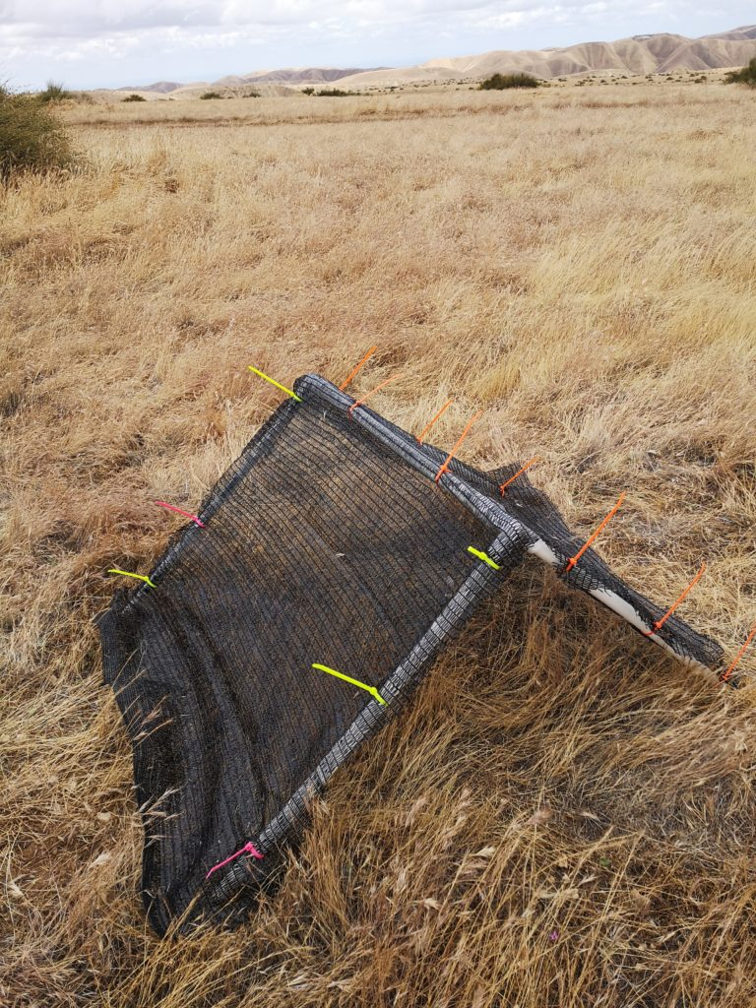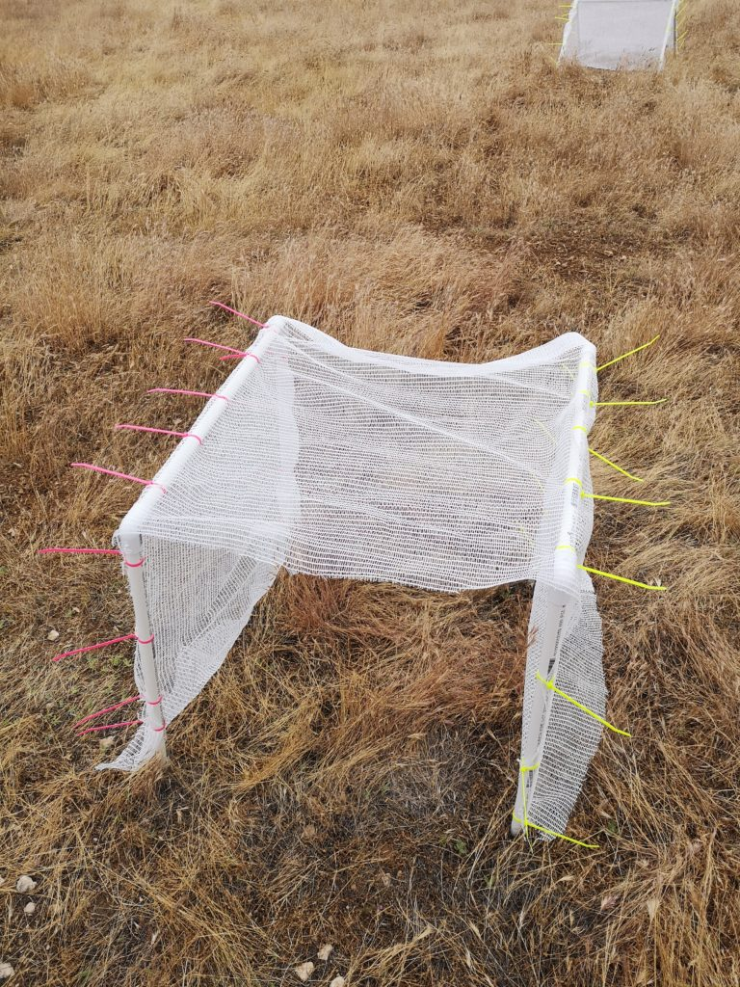

**Figure 1. Left-Triangular shelter with 90% shade cloth attached to PVC skeleton using zip ties. Right-Rectangular shelter with 15% shade cloth attached to two PVC skeletal frames.**

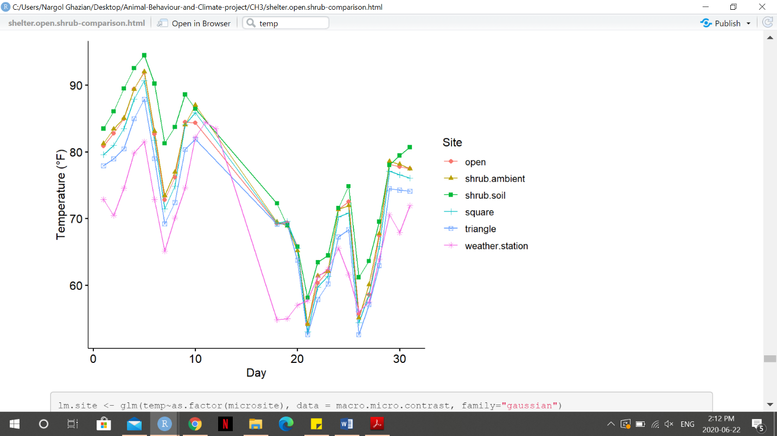

**Figure 2. Mean daily temperature plotted (y-axis, °F) over the course of the study period (x-axis, day) recorded at each microsite and retrieved from *Los Baños* Weather Station. Different shapes represent different microsites/site. Solid lines connect daily means.**

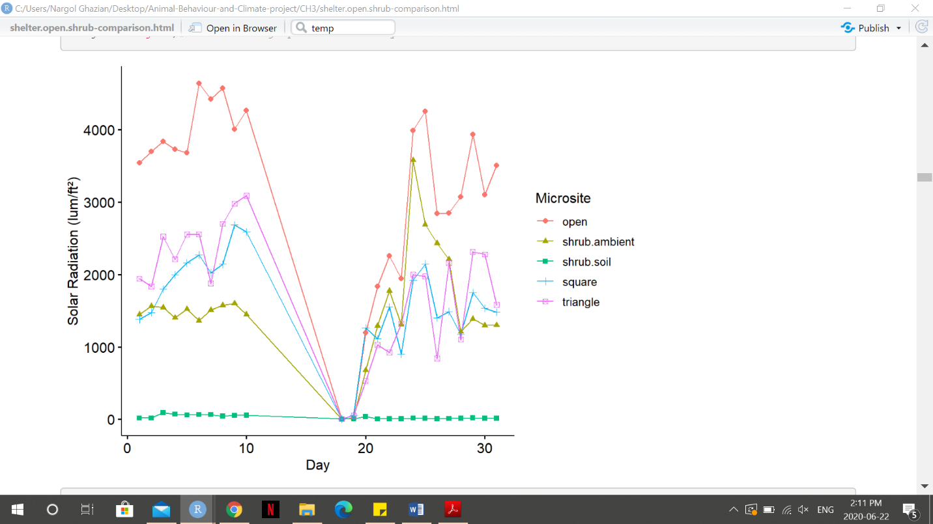

**Figure 3. Mean daily temperature solar radiation (y-axis, lum/ft2) over the course of the study period (x-axis, day) recorded at each microsite. Different shapes represent different microsites. Solid lines daily means.**

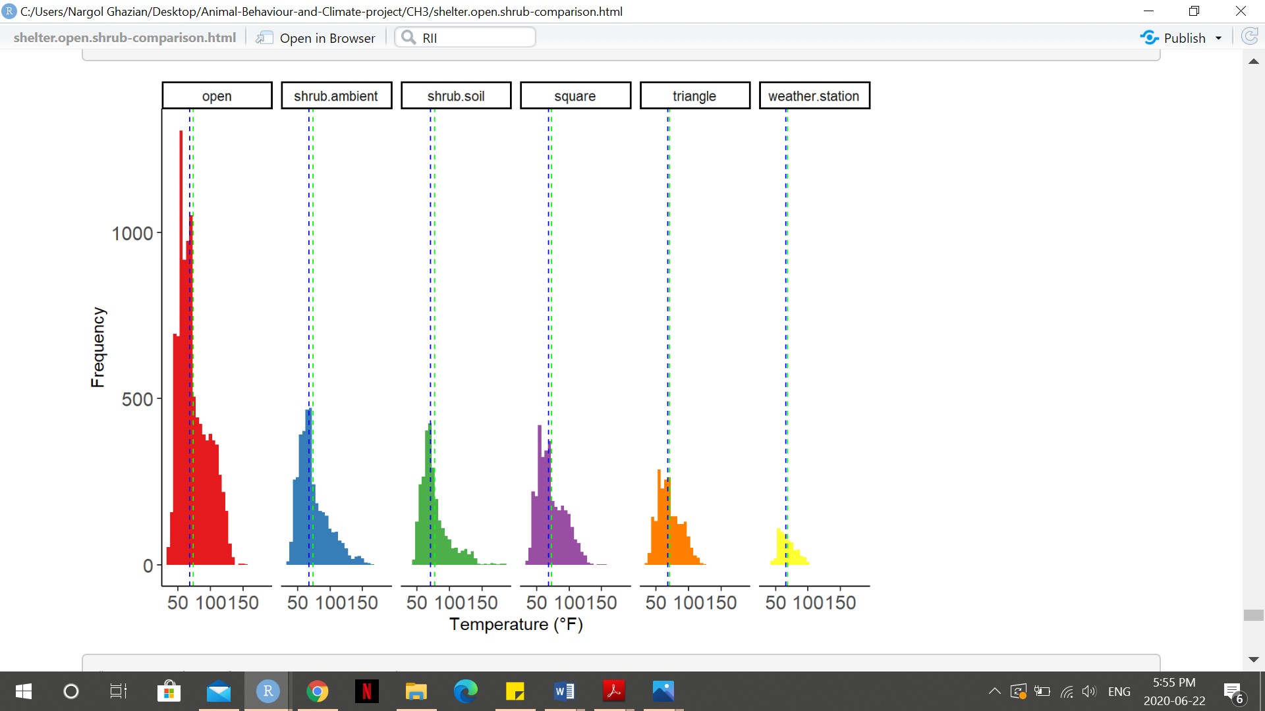

**Figure 4. Frequency histogram of temperatures (°F) recorded at each microsite or weather station. Vertical green dashed line is the mean and the blue dashed line represent the median.**

**Supplementary Appendix**

**A. List of PVC pieces used for shelter skeleton construction is provided alongside the quantity needed to build one of each shelter-type.**

|  |  |  |
| --- | --- | --- |
| **Piece** | **Quantity for Triangular Shelter** | **Quantity for Rectangular Shelter** |
| 61 cm (½ inch diameter) pipe | 4 | 4 |
| 61 cm (¾ inch diameter) pipe | NA | 2 |
| 75 ¾ cm pipe | 1 | NA |
| ½ inch to ¾ inch adapter | 2 | NA |
| ½ inch to ¾ inch 2-way 90º elbow | NA | 4 |
| ½ inch 3-way 90º elbow | 2 | NA |

**B. Location (latitude and longitude coordinates) of each shelter-open and shrub-open microsite is given, alongside its shape and cover type, if applicable.**

|  |  |  |  |  |
| --- | --- | --- | --- | --- |
| **Shelter ID** | **Latitude** | **Longitude** | **Shape (Triangle/Square)** | **Cover type** |
| 1 | 36.69363 | -120.79318 | T | 15% |
| 2 | 36.69364 | -120.79331 | S | 15% |
| 3 | 36.69355 | -120.79315 | S | 90% |
| 4 | 36.69349 | -120.79320 | T | 90% |
| 5 | 36.69349 | -120.79311 | T | 50% |
| 6 | 36.39342 | -120.79311 | S | 50% |
| 7 | 36.69394 | -120.79300 | S | 15% |
| 8 | 36.69397 | -120.79292 | T | 15% |
| 9 | 36.69401 | -120.79282 | S | 90% |
| 10 | 36.694 | -120.79295 | T | 90% |
| 11 | 36.69405 | -120.79305 | S | 50% |
| 12 | 36.69408 | -120.79301 | T | 50% |
| **Shrub ID** |  |  |  |  |
| 1 | 36.69532 | -120.797 |  |  |
| 2 | 36.69592 | -120.797 |  |  |
| 3 | 36.69533 | -120.794 |  |  |
| 4 | 36.69598 | -120.797 |  |  |
| 5 | 36.69591 | -120.797 |  |  |
| 6 | 36.69605 | -120.797 |  |  |
| 7 | 36.69595 | -120.798 |  |  |

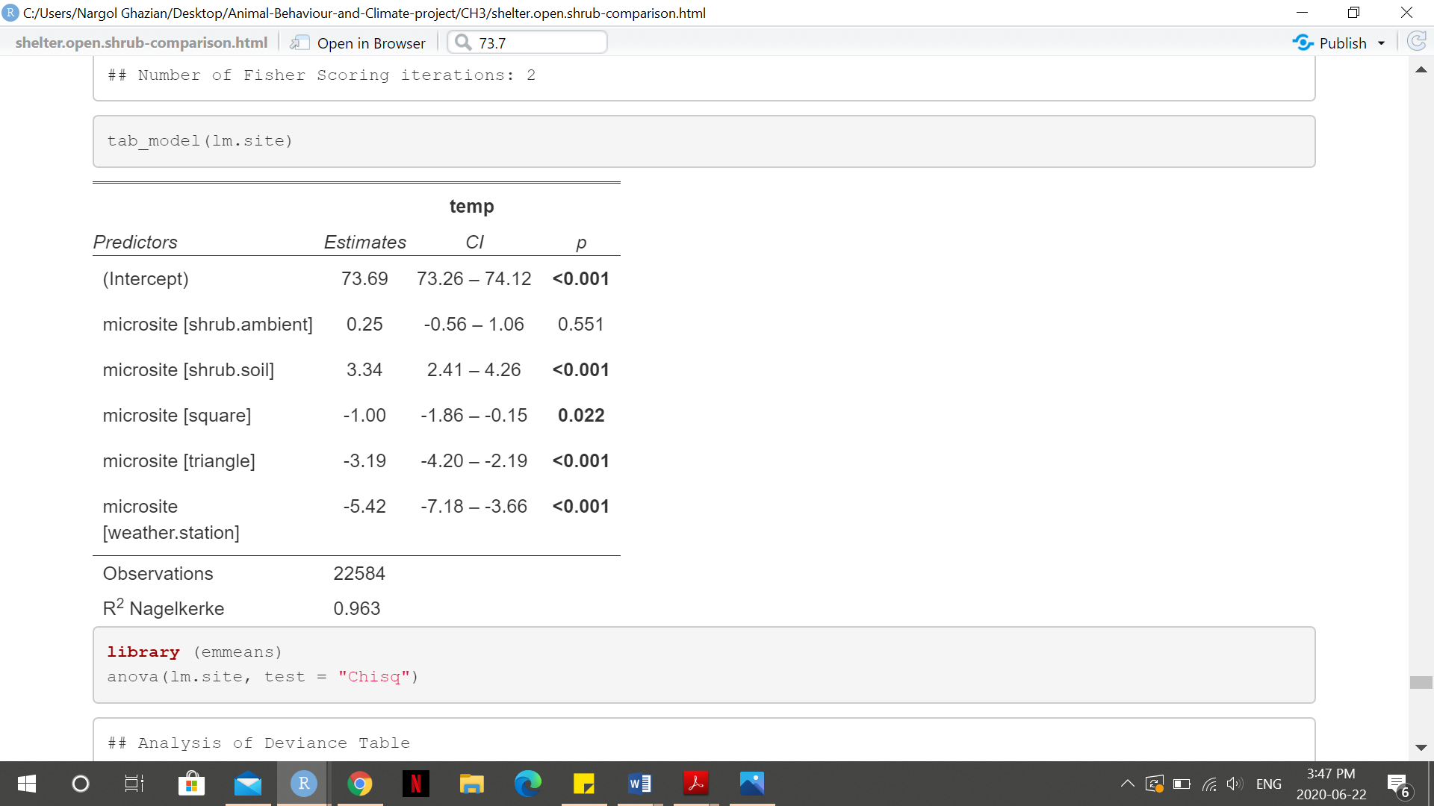**C. Generalized Linear Model (GLM) for temperature (°F) at microsite/site. 95% Confidence Intervals are provided along with the p-value for each microsite. Significant p-values (p<0.05) are bolded.**

**D. Generalized Linear Model (GLM) for solar radiation (lum/ft2). 95% Confidence Intervals are provided along with the p-value for each microsite. Significant p-values (p<0.05) are bolded.**

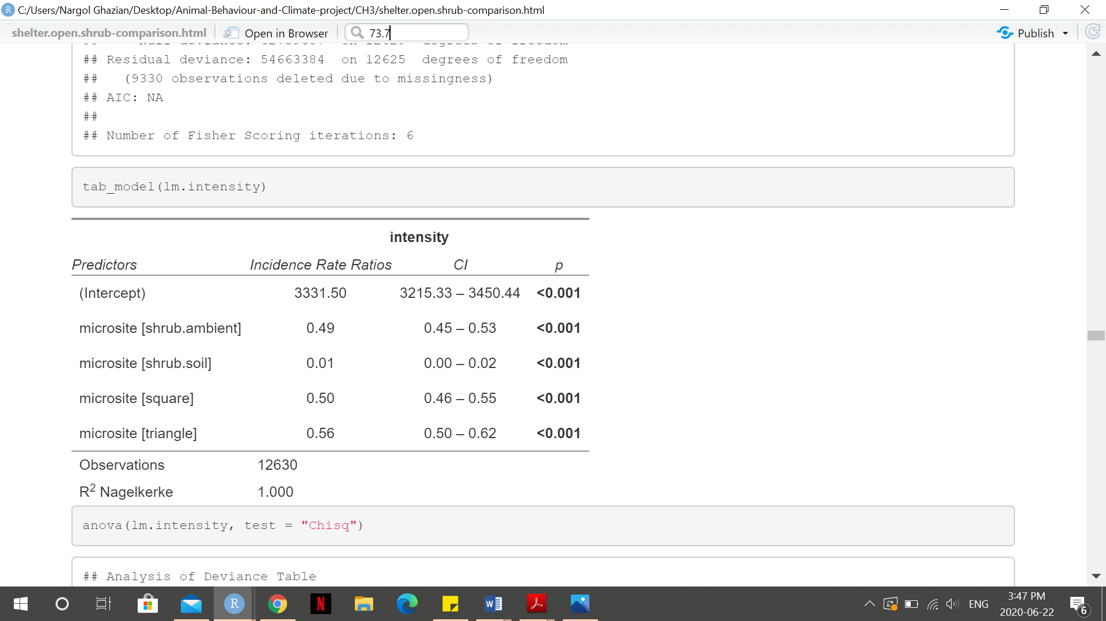

**E. Post-hoc analysis of microsites based on temperature GLM. Standard error and p-values are given. Significant p-values are bolded.**

|  |  |  |  |  |
| --- | --- | --- | --- | --- |
| **Contrast** | **estimate** | **SE** | **z.ratio** | **p-Value** |
| open-shrub.ambient | -0.247 | 0.414 | -0.597 | 0.9913 |
| open-shrub.soil | -3.337 | 0.471 | -7.077 | **0.0001** |
| open-square | 1.005 | 0.437 | 2.298 | 0.1947 |
| open-triangle | 3.195 | 0.512 | 6.238 | **0.0001** |
| open-weather.station | 5.42 | 0.899 | 6.029 | **0.0001** |
| shrub.ambient-shrub.soil | -3.09 | 0.545 | -5.665 | **0.0001** |
| shrub.ambient-square | 1.252 | 0.516 | 2.426 | 0.1473 |
| shrub.ambient-triangle | 3.442 | 0.581 | 5.952 | **0.0001** |
| shrub.ambient-weather.station | 5.667 | 0.94 | 6.030 | **0.0001** |
| shrub.soil-square | 4.342 | 0.563 | 7.708 | **0.0001** |
| shrub.soil-triangle | 6.532 | 0.623 | 10.480 | **0.0001** |
| shrub.soil-weather.station | 8.757 | 0.967 | 9.059 | **0.0001** |

**F. Post-hoc analysis of microsites based on light intensity GLM. Standard error and p-values are given. Significant p-values are bolded and confidence level used is 95%. Results are given on the log scale.**

|  |  |  |  |  |
| --- | --- | --- | --- | --- |
| **Contrast** | **estimate** | **SE** | **z.ratio** | **p-Value** |
| open-shrub.ambient | 0.7161 | 0.0452 | 15.842 | **0.0001** |
| open-shrub.soil | 0.5889 | 0.4146 | 11.068 | **0.0001** |
| open-square | 0.6873 | 0.0473 | 14.539 | **0.0001** |
| open-triangle | 0.5821 | 0.0543 | 10.718 | **0.0001** |
| shrub.ambient-shrub.soil | 3.8728 | 0.4163 | 9.304 | **0.0001** |
| shrub.ambient-square | -0.0287 | 0.0602 | -0.477 | 0.9895 |
| shrub.ambient-triangle | -0.134 | 0.0659 | -2.032 | 0.2505 |
| shrub.soil-square | -0.9015 | 0.4165 | -9.367 | **0.0001** |
| shrub.soil-triangle | -4.0068 | 0.4174 | -9.600 | **0.0001** |
| square-triangle | -0.1052 | 0.0674 | -1.562 | 0.5218 |

**G. Summary of Analysis of Deviance (ANOVA) for RII from GLM. Microsite was treated as factor.**

|  |  |  |  |  |  |  |
| --- | --- | --- | --- | --- | --- | --- |
|  |  | **df** | **Deviance Resid.** | **df Resid.** | **Dev** | **Pr(>Chi)** |
| **Measure:** |  |  |  |  |  |  |
| **RII** | **NULL** |  |  | 61 | 0.025029 |  |
|  | **as.factor (microsite)** | 5 | 0.0014171 | 59 | 0.023612 | 0.1703 |

**H. Estimated Marginalized Mean (EMM) and standard error (SE) are given for each microsite based on RII GLM. Results. Confidence Interval used is 95%.**

|  |  |  |  |  |
| --- | --- | --- | --- | --- |
| **Microsite** | **emmean** | **SE** | **Asymp.LCL** | **Asymp.UCL** |
| shrub.ambient | 0.00309 | ±0.00535 | -0.007393 | 0.01357 |
| square | -0.00308 | ±0.00408 | -0.011088 | 0.00492 |
| triangle | 0.00776 | ±0.00408 | -0.000245 | 0.01576 |

**I. Left- General PVC triangular structure and joint. Right-Metal stake and with PVC pipe slid on.**

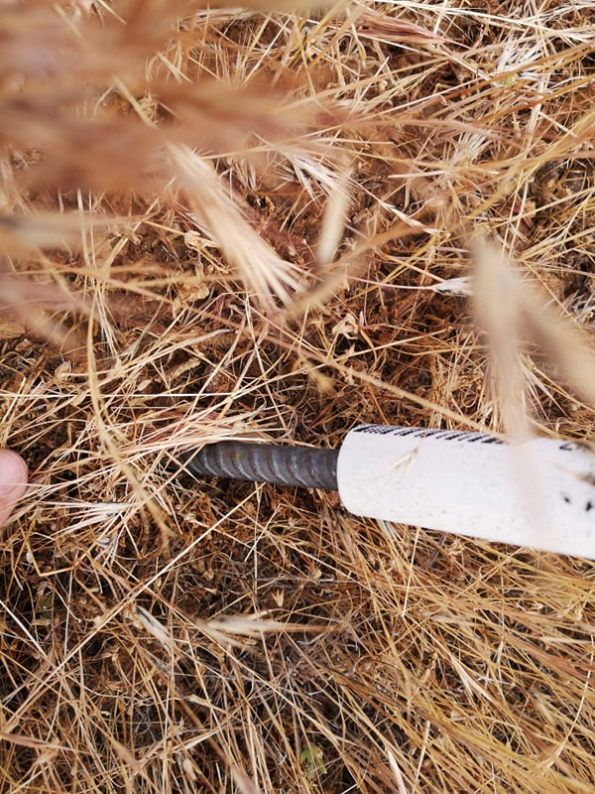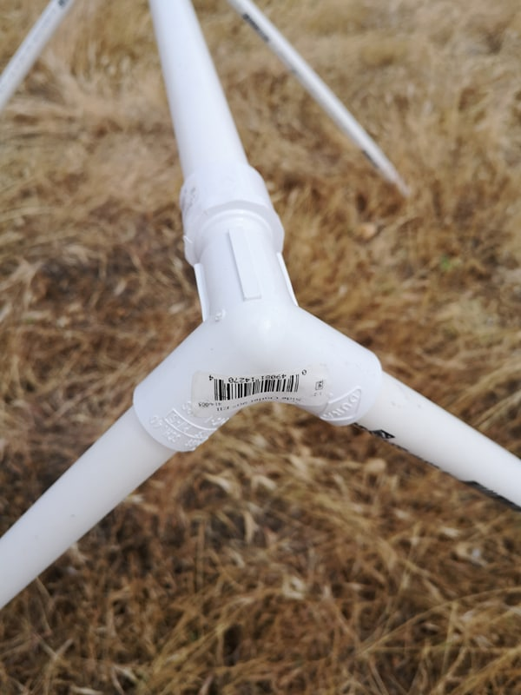

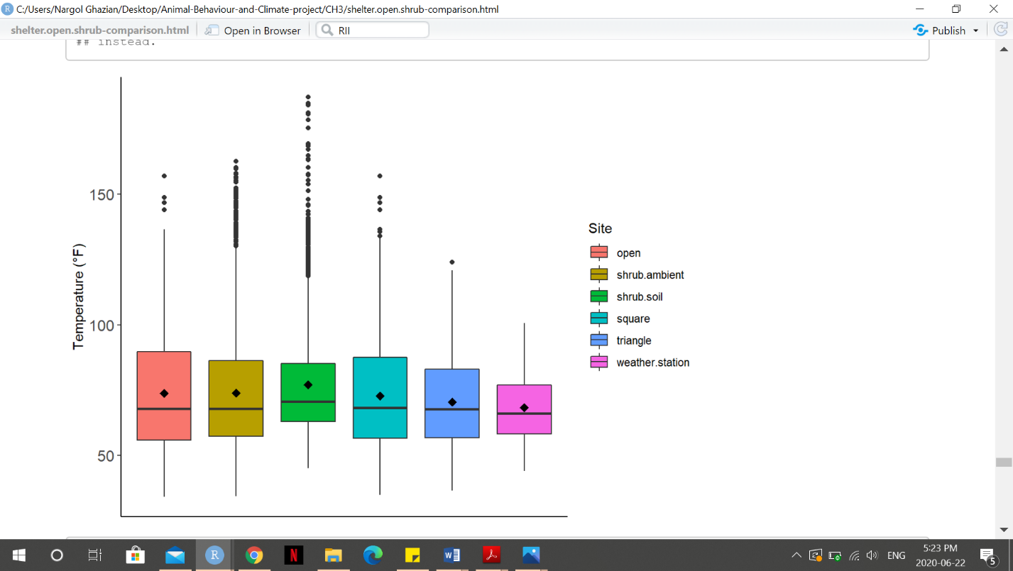**J. Box plot showing ambient temperature (°F) at each site. Solid middle lines shows the median of the data, whilst whiskers show 1.5 standard deviation. Solid dots are outliers >1.5 interquartile range (IQR). Diamonds dots represent the mean.**

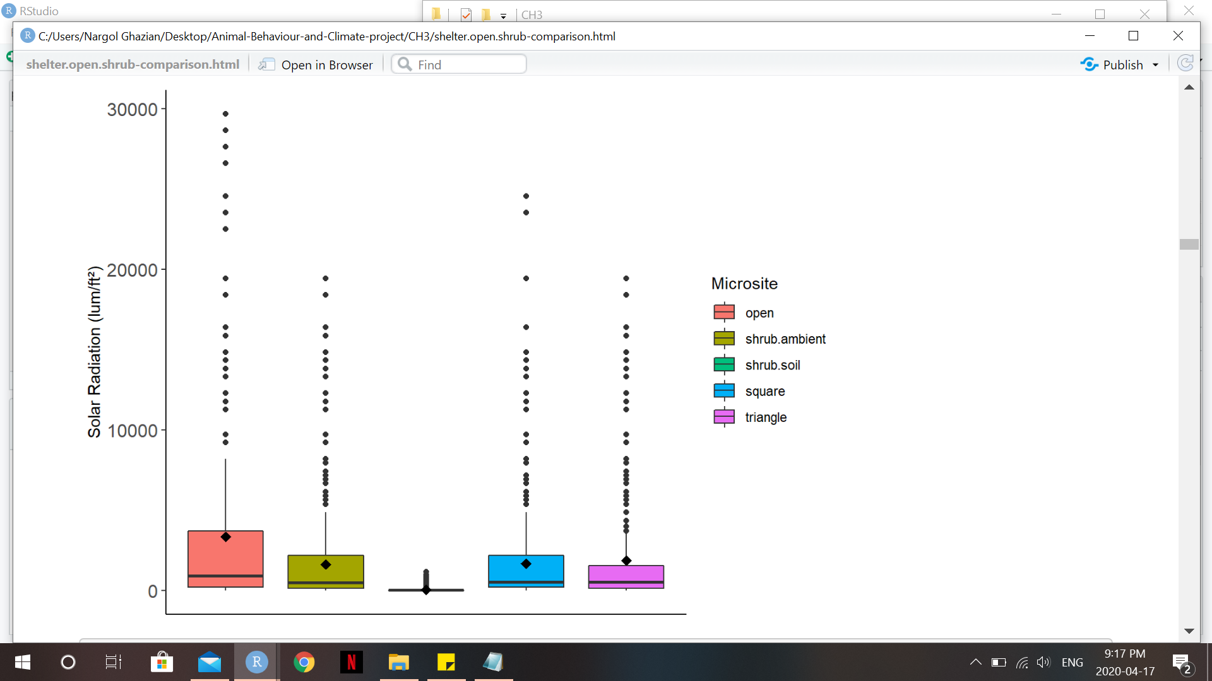

**K. Box plot showing light intensity (lum/ft2) at each microsite. Solid middle lines shows the median of the data, whilst whiskers show 1.5 standard deviation. Solid dots are outliers >1.5 interquartile range (IQR). Diamonds dots represent the mean.**

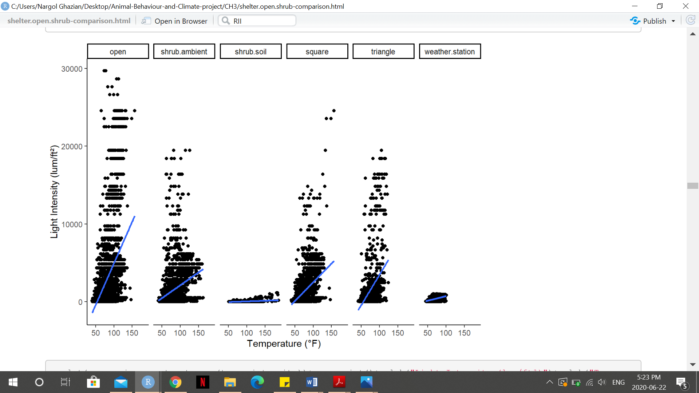

**L. Scatterplot showing the relationship between solar radiation (lum/ft2) and temperature (°F) at each microsite (Overall Kendall’s tau=0.281, p=0.0001). Blue lines represent smooth conditional mean fitted using the method GLM.**

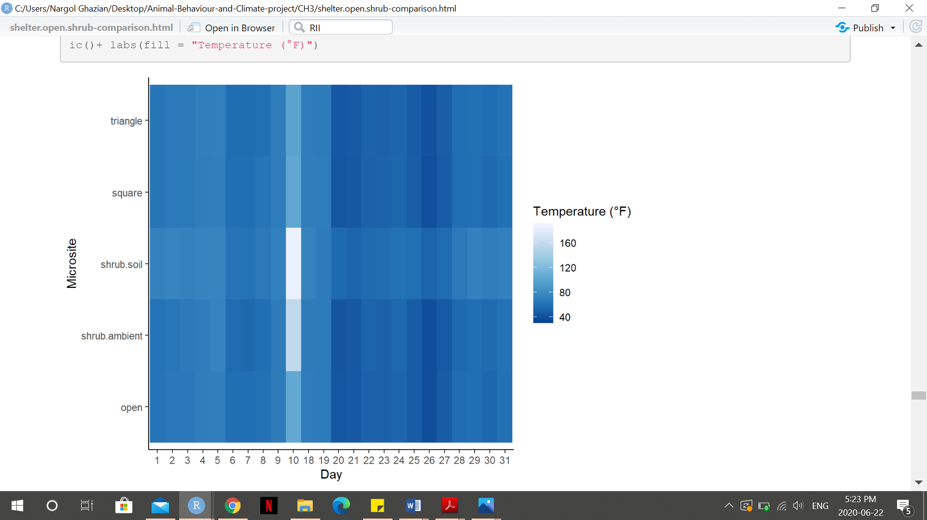**M. Heat Map visualizing temperature (°F) during the study period at the different microsites. Darker red colours corresponds to cooler temperature whilst bright yellow colours correspond to warmer temperatures.**

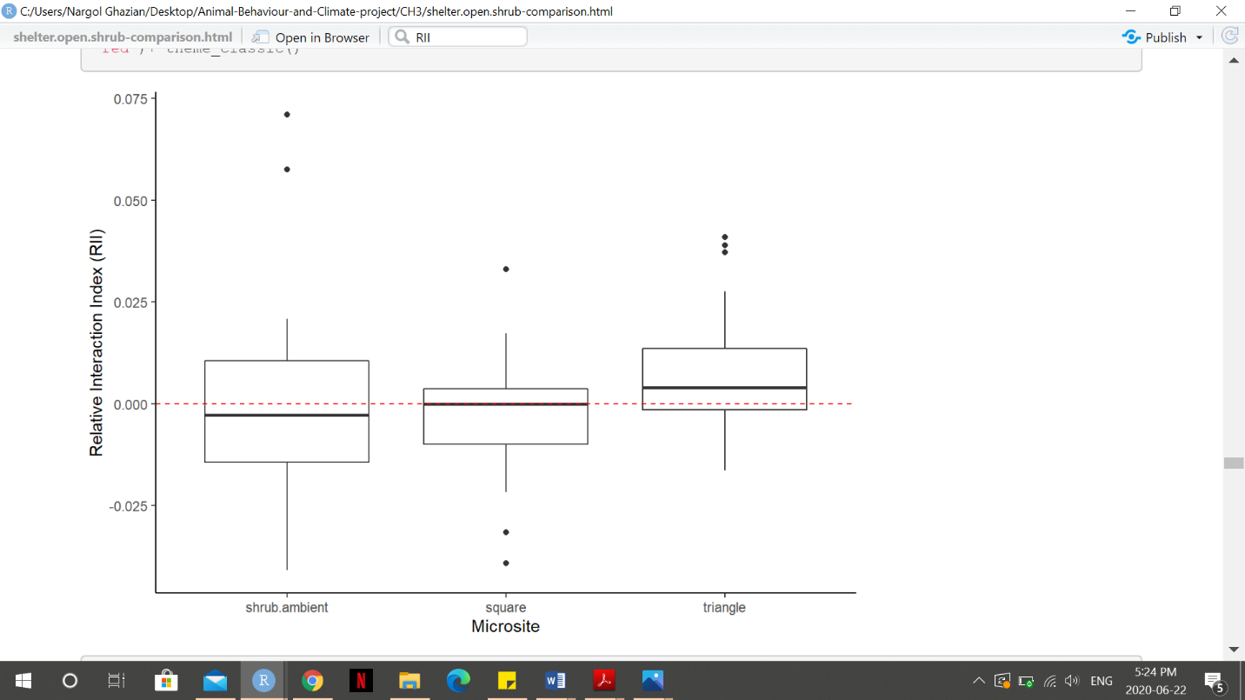

**N. Box plot showing light the Relative Index of Interaction (RII) for each canopy type. Solid middle lines shows the median of the data, whilst whiskers show 1.5 standard deviation. Solid dots are outliers >1.5 interquartile range (IQR). The index values range from -1 to +1. Red dashed line represent 0, or a neutral interaction.**

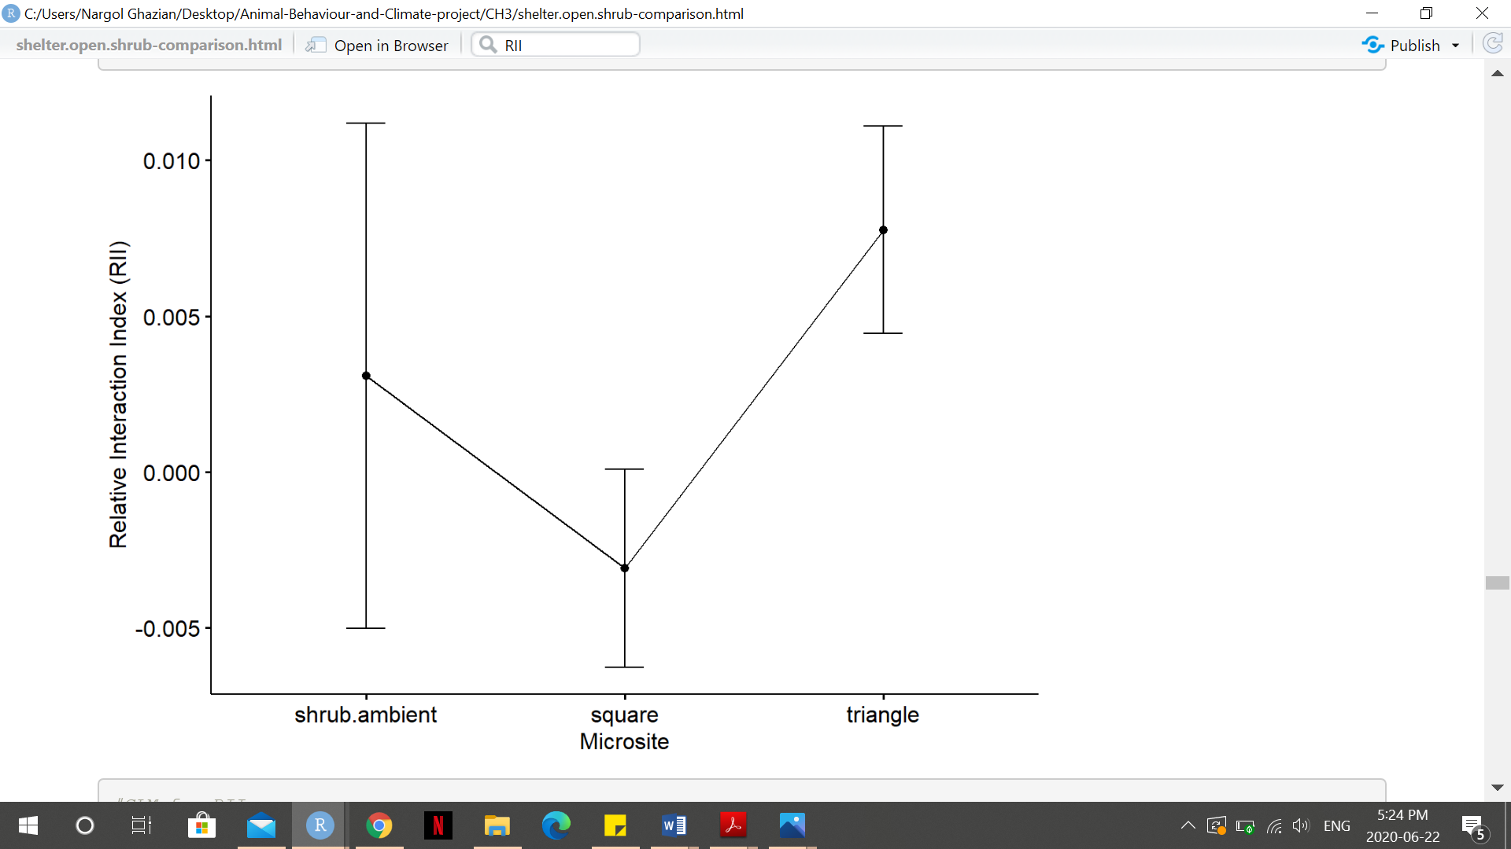

**O. Mean point and SE plot of RII for each canopies microsite.**

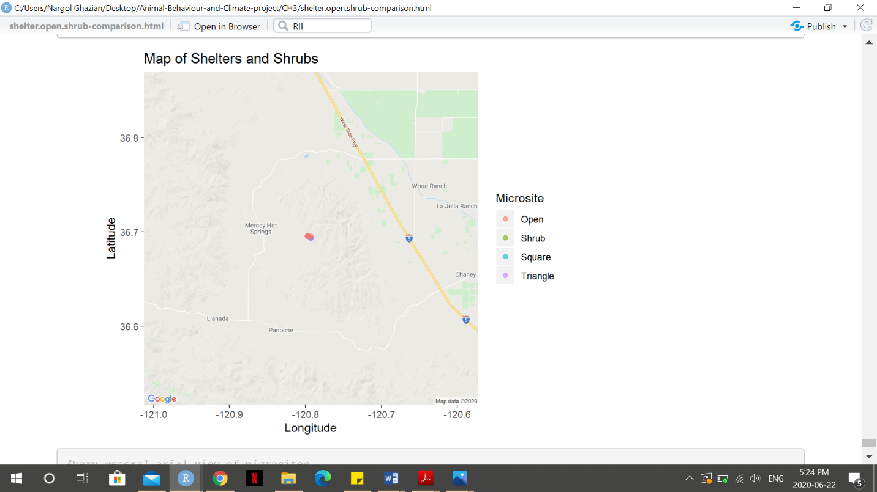

**P. Map of microsites at Panoche Hills Conservation Area in California.**